U1E1: Repaso

Nombre: ________________________________
Hora: __________ Fecha: ________________

Parte 1: Comprensión auditiva (Listening)
Criterio 1.2: Students understand and interpret written and spoken language on a variety of topics.

Instrucciones: Listen to la maestra and illustrate what each person is like with as much detail as possible.
Persona A | Persona B

Parte 2: Escritura (Writing)
Criterio 1.3: Students present information, concepts, and ideas to an audience of listeners or readers on a variety of topics.
Instrucciones: Write as much as you can about the information presented in the box below.
- ________________________________________________________________________________________________________________________________________

Pedro Pérez

Madrid
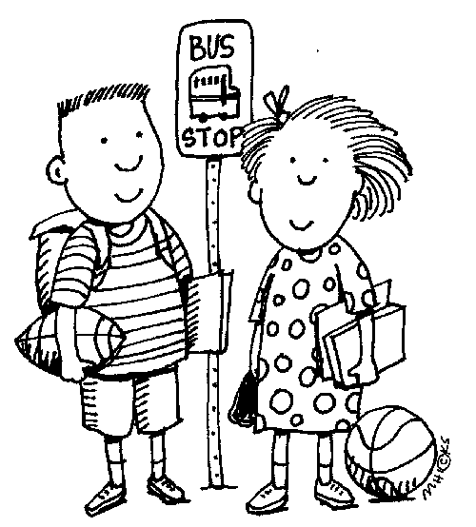
- ________________________________________________________________________________________________________________________________________
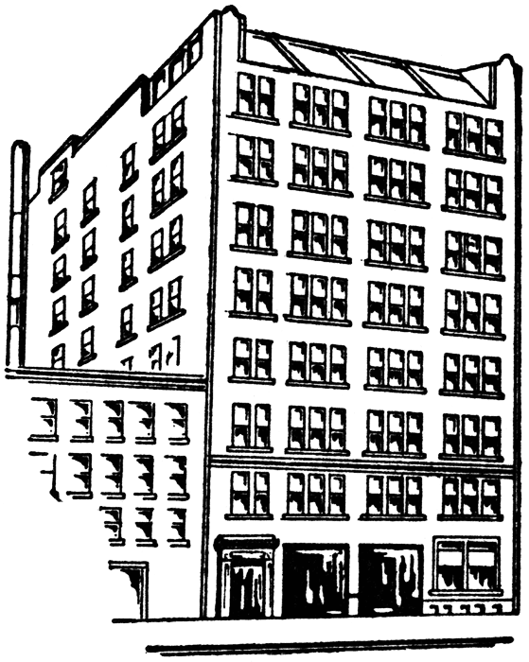
- ________________________________________________________________________________________________________________________________________
- ________________________________________________________________________________________________________________________________________
- ________________________________________________________________________________________________________________________________________
- ________________________________________________________________________________________________________________________________________
Parte 3: Lectura (Reading)
Criterio 1.2: Students understand and interpret written and spoken language on a variety of topics.

Instrucciones: Read the short stories and illustrate them as completely as possible in the boxes below. You want to show how much you understand—¡los detalles son buenos!

- ¡Buenas tardes! Me llamo Beto Chávez. Soy de la capital de la República Dominicana. Soy doctor. Vivo en un apartamento—no vivo en una casa. Me gusta trabajar. Me gusta escribir también, pero no me gusta correr ni comer.
- Te presento a mi amiga Inés Vargas. Es policía. Es de la capital de Uruguay y vive en una casa. Le gusta bailar y cantar. También le gusta leer y nadar, pero no le gusta patinar.

1. | 2.

